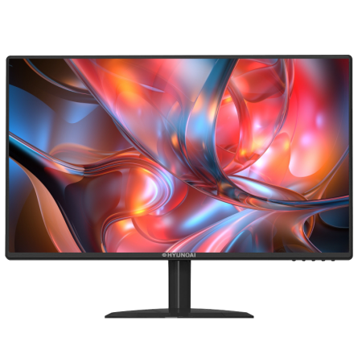
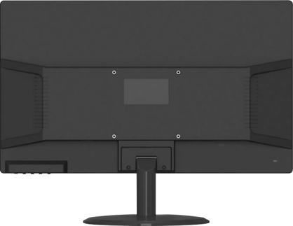
 | Model name |  | 型号名称 | E200A-P
SPC | Size |  | 尺寸 | 19”
 | Resolution |  | 分辨率 | 1440x 900
 | Refresh rate |  | 刷新率 | 60 Hz
 | Panel brand |  | 屏幕品牌 | /
 | Panel type |  | 屏幕类型 | VA/TN
 | Active Area |  | 可视范围 | 409.5(W)×255.94(H) mm
 | Dot Pitch |  | 像素点 | 0.24375*0.24375 mm
 | Aspect ratio |  | 屏幕比例 | 16:10
 | Backlight |  | 背光 | LED
 | Typical Brightness |  | 最佳亮度 | MAX:250cd/M²
 | Contrast Ratio |  | 对比率 | 1000:1
 | Color Temp. default |  | 默认色彩度数 | default:7500K 6500/7500/9300
 | Number of colors |  | 色数 | 16.7M
 | Color |  | NTSC | 72%
 |  |  | sRGb | 92%
 |  |  | Adobe RGB | 71%
 | Viewing Angle |  | 可视角度 | 178/178 (H/V)
 | Response Time |  | 反应时间 | 5ms
 | I/O Ports |  | 端口 | HDMI+VGA+DC
 | NOTES |  | VGA参数 | VGA1.4
 |  |  | HDMI参数 | HDMI1.4
 |  |  | DP参数 | /
 |  |  | USB参数 | /
 | Speaker |  | 喇叭 | /
 | Audio Ports |  | 音频端口 | /
PSU | Input |  | 输入 | 100-230DC/AC 50/60HZ 12V/2.5A
 | Type |  | 类型 | Adapter
 | Power Consumption |  | 功率 | Max:30W STB ≤0.5W
Structure  结构 | Stand |  | 标准 | Standard
 | Colors |  | 外观颜色 | Front frame: black
 |  |  |  | Back cover: black
 |  |  |  | Stand: black
 |  |  |  | Base:black
 | Size | W/ Base | 含底座尺寸 | 440*200*290mm
 |  | W/O Base | 不含底座尺寸 | 440*20*290mm
 |  | Pacakge | 包装尺寸 | 485*105*345mm
 | Weight | N.W | 净重 | 1.85KG
 |  | G.W | 毛重 | 2.6KG
 | Tilt |  | 倾斜角度 | Forerake 5°，Fadeaway 25°

 | VESA Mounting | VESA安装 | 75*75mm
 | Rotating angles | 旋转角度 | /
 | High Adjustable Arm | 高度调节 | /
 | Swivel | 旋转 | /
Panel Control  屏幕控制 | Control Way | 控制方式 | Key OSD
 | Language Menu | 语言菜单 | 7 languages max
Environment  环境 | Storage Temp. | 允许温度 | -20ºC~60ºC
 | Working Temp. | 工作温度 | -10ºC~40ºC
 | Working Humidity | 工作湿度 | 10~90%RH
 | Altitude | 可行高度 | ≤5000m
 | MOQ for OEM/Each model | 起订量 | 1000 pcs

